LAB 3

TITLE: Implementation of Shortest Job First (SJF) CPU Scheduling Algorithm in C

OBJECTIVE:
To implement the Shortest Job First (SJF) CPU scheduling algorithm in C and calculate:
- Waiting Time (WT)
- Turnaround Time (TAT)
- Average Waiting Time
- Average Turnaround Time

THEORY:
Shortest Job First (SJF) is a non-preemptive scheduling algorithm where the process with the shortest burst time is executed first. This improves the average waiting time compared to FCFS.

Characteristics:
- It is based on burst time, not arrival time (in non-preemptive).
- Shorter jobs are prioritized, which reduces waiting time.
- If burst time is not known in advance, it can be difficult to implement practically.

Terminologies:
- Burst Time (BT): Time needed for process execution.
- Waiting Time (WT): Time a process waits before execution.
  - WT[i] = ∑ BT of all previous sorted processes
- Turnaround Time (TAT): Total time from arrival to completion.
  - TAT[i] = WT[i] + BT[i]
- Average Waiting Time (AWT):
  - AWT = ∑WT / n
- Average Turnaround Time (ATAT):
  - ATAT = ∑TAT / n

Algorithm:
- Start
- Input number of processes n
- Input burst time for each process
- Assign process IDs
- Sort processes by burst time in ascending order (SJF logic)
- Set waiting time of first process = 0
- For remaining processes:
- WT[i] = WT[i-1] + BT[i-1]
- TAT[i] = WT[i] + BT[i]
- Calculate average WT and TAT
- Display all data
- End

PROGRAMS
#include <stdio.h>

// Structure to represent a process
struct Process {
int pid; // Process ID
int burst; // Burst time
int waiting; // Waiting time
int turnaround; // Turnaround time
};
int main() {
int n, i, j;
float avg_waiting = 0, avg_turnaround = 0;

printf("Enter number of processes: ");
scanf("%d", &n);

struct Process proc[n], temp;

// Input burst times for each process
for(i = 0; i < n; i++) {
printf("Enter burst time for process P%d: ", i + 1);
scanf("%d", &proc[i].burst);
proc[i].pid = i + 1; // Assign process IDs
}

// Sort processes by burst time (SJF)
for(i = 0; i < n - 1; i++) {
for(j = 0; j < n - i - 1; j++) {
if(proc[j].burst > proc[j + 1].burst) {
// Swap processes
temp = proc[j];
proc[j] = proc[j + 1];
proc[j + 1] = temp;
}
}
}

// Calculate waiting and turnaround times
proc[0].waiting = 0; // First process has 0 waiting time
proc[0].turnaround = proc[0].burst;

for(i = 1; i < n; i++) {
proc[i].waiting = proc[i - 1].turnaround;
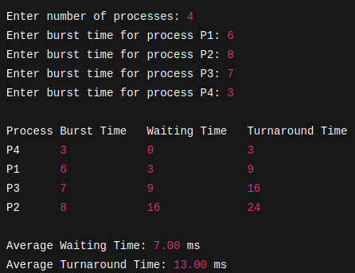
proc[i].turnaround = proc[i].waiting + proc[i].burst;
}

// Calculate averages
for(i = 0; i < n; i++) {
avg_waiting += proc[i].waiting;
avg_turnaround += proc[i].turnaround;
}

avg_waiting /= n;
avg_turnaround /= n;

// Print results
printf("\nProcess\tBurst Time\tWaiting Time\tTurnaround Time\n");
for(i = 0; i < n; i++) {
printf("P%d\t%d\t\t%d\t\t%d\n",
proc[i].pid, proc[i].burst, proc[i].waiting, proc[i].turnaround);
}

printf("\nAverage Waiting Time: %.2f", avg_waiting);
printf(" ms\nAverage Turnaround Time: %.2f ms\n", avg_turnaround);

return 0;
}

Output:

RESULTS:
The Shortest Job First (SJF) scheduling algorithm was successfully implemented. The program accurately calculated the waiting time, turnaround time, and their averages based on burst time sorting.

CONCLUSION:
SJF scheduling reduces the average waiting time compared to FCFS. This lab provided understanding of:
- Sorting processes by burst time
- Calculating efficient process scheduling
- Trade-off between fairness and efficiency in scheduling algorithms

